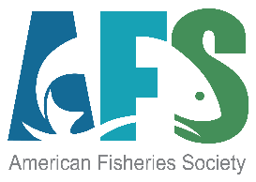
American Fisheries Society
August 2024
Management Committee Minutes

Key Motions and Tasks:
- Approval of the Instream Flow Council request for support.
- Approval of name change and Procedures language request for the standing committee on Diversity, Equity and Inclusion to be changed to “FishCAST - Fisheries Community Advocacy for (and) Sustainability Team”. Procedures will be incorporated into the AFS document. The name change is an AFS Rules change and will be forwarded to the Governing Board and AFS membership.
- The Executive Director Search process was completed with the selection of Jeff Kopaska. Final contract language is being completed between Cecil Jennings and Kopaska.
- AFS Awards process review and revision: A working group was developed to assist Lauren Maza with review of all society-level awards. This committee includes Margaret Murphy, Cecil Jennings, Jeff Kopaska, Gary Whelan. They will also ask some recent award winner to assist.
- Removal of the AFS Vote Auditor from the AFS Rules and Procedures will be proposed at an upcoming MC or GB meeting. This position was suggested as outdated given new vote methodology.
- AFS Dues update. Based upon current Management Committee guidance, the 2024-2025 dues year is subject to a possible cost-of-living increase. This will be evaluated and a proposal will be made to the MC or GB at the Honolulu meeting.

Minutes of the Meeting:

Participants:
Management Committee Members:
Cecil Jennings, Miguel Garcia Bermudez, Gary Whelan, Margaret Murphy, Dan Mosier, Lynn Quattro, Dan Isermann, Jeff Kopaska, Heather Stewart, Tim Copeland (Proxy for Julie Carter), Laurie Earley (Proxy for Eric Fetherman), Randy Schultz (Constitutional Consultant, non-voting), Doug Austen (Executive Director, non-voting)

ELMA: Drew Holloway, Matthew Wipf, Andrew Bade, Kyler Hecke

Guests:
Marlis Douglas, 2nd President Elect
Jory Jonas, Co-chair, Diversity, Equity, and Inclusion Committee
Nivette Perez-Perez, Co-chair, Diversity, Equity, and Inclusion Committee

AFS Staff: Dan Cassidy, Kelly Kotche, Lauren Maza, Laura Hendee, Beth Beard, Jenna Hanks, Shawn Johnston, Lauren Tanner

- Greetings, Recognition of Proxies, and Determination of Quorum (need 7 members) – Cecil Jennings and Randy Schultz. Established proxies are:
  - Fisheries Management Section – Tim Copeland for Julie Carter
  - Western Division – Laurie Earley for Eric Fetherman
  - Fish Culture Section – Matthew Wipf for Dan Mosier
- Approval of Agenda- Miguel Garcia-Bermudez and Randy Schultz.
Motion to approve agenda by Gary Whelan; 2nd by Lynn Quattro. Approved with unanimous consent.

- Review of July 2024 Management Committee Meeting. Motion to approve July meeting minutes by Gary Whelan; 2nd by Heather Stewart. Approved with unanimous consent.

- Constitutional Consultant Report - Randy Schultz
  - Motion: Instream Flow Council request for support (Attachments A1 and A2)
Background: AFS has been a long-time partner with the Instream Flow Council (IFC). The IFC, through support of a Multistate Conservation Grant and a team of 10 authors (including many AFS members and the AFS Executive Director), completed a Feasibility Assessment and business plan to establish a “Training, Research, and Development Center To Support Instream Flow And Water Level Conservation”. This motion to provide AFS support for the center is a companion motion that will be presented to the AFWA Governing Board at their annual meeting September 22-25, 2024, in Madison, WI.
Motion to approve AFS endorsement of Instream Flow Council recommendation by Gary Whelan, 2nd by Lynn Quattro. Approved with unanimous consent.

- Motion: To adopt a name change for the standing committee on Diversity and Inclusion and new procedures to guide the committee (Attachment B)
Background: The DEI standing committee has been active for about three years. However, upon approval to advance the committee from a special committee to a standing committee, no procedures were adopted. This revision updates the committee name to better reflect its activities and establishes procedures for composition and activities of the committee. Because committee names are in the AFS Rules, one component of the motion will need to include a recommendation that the name change be approved by the Governing Board and presented to the AFS membership at the annual business meeting in Honolulu.
Jory Jonas, co-chair of the DEI committee provided additional background on the proposed name change and the procedures. Key points presented by Jory include:
  - Current politics have placed led to unfortunate and undesired confusion about the acronym DEI. The committee does not want to be impacted or adversely affected by political impacts and the name change will eliminate that association.
  - DEI frequently is not associated with work to fully include indigenous inclusion and the name change opens up the committee for important work on this important issue.
  - The name was recommended by members of the North Central Division and has been reviewed by the Equal Opportunities Section and others. Many names were explored but this proposed name seemed to best address the goals and purpose.
  - The committee should be a gathering place for awareness and information about the many DEI-related activities throughout AFS. They will act as a clearinghouse for information.
  - Specific duties of the committee were reviewed as presented in the proposed language.
  - The committee does have a role in helping to coordinate DEI activities at the annual meeting and participates in the planning committees of the meetings.
Proposed Motion A: To recommend to the Governing Board and the AFS membership that they take the appropriate actions to modify the AFS Rules to reflect a change in the name of the Standing Committee on Diversity and Inclusion to be “FishCAST - Fisheries Community Advocacy for (and) Sustainability Team”
Motion to approve name change recommendation and to refer with full support to the Governing Board made by Gary Whelan with 2nd by Dan Mosier. Approved with unanimous consent.
Proposed Motion B: To adopt the new proposed procedures for the Diversity and Inclusion Standing Committee and update the name to reflect the final approved name once adopted by the Governing Board and AFS membership.
Motion to approve the adoption of procedures (including name change adjustment if approved by the Governing Board and membership) for the Diversity and Inclusion Committee made by Gary Whelan with 2nd by Miguel Garcia-Bermudez. Approved with unanimous consent.
- Officers Reports
  - Cecil Jennings, President. Attended the FSBI meet in Bilboa, Spain. The FSBI meeting is designed with a single session that all participants attend. Explored publishing contracts with FSBI leaders who currently and recently re-signed with Wiley. Next year, FSBI will be meeting in Northern Ireland. The Executive Director search has also taken significant time.
  - Miguel Garcia Bermudez, President Elect. Preparing for the move to the AFS president role that will start at the annual meeting. Thinking about midyear meeting scheduling and finished his first Presidents message for Fisheries. Attended the Iberian Society meeting near Barcelona, Spain. Presented on the history of AFS and fisheries in the U.S. Working with the Texas chapter on the 2025 AFS San Antonio annual meeting.
  - Gary Whelan, 1st Vice President. Assisting with multiple ethics investigations as part of the AFS Ethics and Professional Conduct Committee. This has also led to the recognition that better procedures need to be developed for this committee. Has been helping to revive the AFS Fisheries History Section. They have a full slate of officers and should be fully active by the AFS Honolulu meeting. Starting to develop his plan of work for the 2025-2026 AFS year and hopes to have a draft by the Hawaii annual meeting. Assisting with AFS Membership Committee and engaging the Fisheries Administration in these talks. Also helping with the Moberly Award and the AFS Fishing Buddy Program.
  - Margaret Murphy, 2nd Vice President. Supporting the Membership Committee and their action plan to maintain or expand membership. Margaret is working on ways to eliminate the chapter-only member option but recognizes that this will be a significant challenge over multiple years. Working on the JASM2028 planning committee.
- Update on ED Search – The committee work has formally concluded with the signing of a contract with Jeff Kopaska to be the new Executive Director starting in late August/early September. Austen and Kopaska have been talking regularly about the transition and have included Jeff in staff meetings as well as conversations with several key staff. Austen will continue to address a couple of roles during the transition (e.g., continue as Secretary General of WCFS and represent AFS on the NFHP), but most roles will move to Jeff by the Honolulu meeting. Jeff will also represent AFS at the AFWA annual meeting in Madison, WI, the week after AFS Honolulu. In coordination with TWS CEO Ed Arnett, Jeff will be meeting with state agency directors and many others to discuss the important role of science societies.
- Focused Discussion
  - AFS Awards Committee Restructuring (Attachment C) – Lauren Maza presented a summary of key issues and challenges with the award process for AFS national level awards (e.g., primarily those presented at the Plenary Sessions of the annual meeting). Issues include confusion about eligibility for awards and need for better definitions, some awards receive very few applications whereas others are rich in applications, need to have all committees use the AwardsForce application software. Additional suggestions may include a merger of a few awards that substantially overlap, reviewing language in AFS Procedures Manual. Specific request is to identify several volunteers to work on a small task force to help review the awards program and provide recommended improvements to the Management Committee over the next several months.
Those who have volunteered include Margaret Murphy, Cecil Jennings, Jeff Kopaska, Gary Whelan. We should also ask some recent award winner to assist.
  - Review of Vote Auditor removal from AFS Rules and Procedures (Attachment D) – Austen briefly reviewed the proposal to remove the Vote Auditor as part of the AFS election process. This role goes back to the old paper ballot election process that is not used anymore. The current Balloteer system is highly secure and has no use for an outside auditor to count votes. The included summary is a draft but needs additional clarification to address additional references in the Procedures manual. No action requested today but a fully developed proposal will be presented as future MC meetings.
  - Dues update discussion with AFS Membership Committee (Dan Cassidy, Kelly Kotche and committee representatives)
    - AFS reviews membership dues every two years with the most recent being the 2022-2023 year. We are currently evaluating dues increases for the 2024-2025 year. This would potentially include an inflation-based proposal as approved in the guidance. This will be proposed to the Management Committee at the next meeting in September.
    - Early this fall, before the 2024-2025 membership renewals are sent, the AFS leadership will be presented with a set of options for consideration.
- Executive Director and AFS staff reports
  - Books Program Review – final executive summary (Attachment E; Laura Hendee). The draft final executive summary was presented for review. A more complete financial table will be included in the final product. These reviews will be revisited every 3 years or so.
  - Honolulu activities and status report (Shawn Johnston and others).
    - Registration exceeded 1,800 and 60 booths sold and only four remain available. This has exceeded expectations. The Spawning run has over 200 registrants, over 300 have signed up for the Mentor-Mentee program. Service-learning project sign-ups has exceeded 150 registrants.
    - Still waiting for approval from the Department of Interior agencies.
    - Hotel room blocks close tomorrow and we have exceeded the contractual minimums at all hotels. There is a possibility of a hotel worker strike at one hotel but this should be completed prior to the AFS event.
    - The Honolulu meeting app is now available.
    - A Scheduled-at-a-glance is being developed.
  - Financial update (Cassidy; Attachment F). Key points include:
    - Audit report has been finalized and shared with the FPPC. Some points of interest include a slight increase in total assets compared to 2022 but this has been impacted by some on-time events such as the World Fisheries Congress. 2023 showed an operating loss but this was offset by investment gains. Just the opposite was shown in 2022 where there was a $463,000 operating gain, but investment loss was $920,000. It was reported that the final covid payment is likely to be released in the next couple of weeks.
    - June 2024 compared to June 2023 shows a positive net operating change. Unfortunately, due to losses incurred from the World Fisheries Congress, we anticipate a net operating loss for the new. However, the Honolulu meeting performance will have a significant effect on the final result.
    - AFS investment portfolio has performed well in 2024. Cash flow is very strong but primarily due to Honolulu receipts. This will, obviously, change once we receive bills for the various events. This also includes the $450,000 signing payment from Oxford University Press
    - Glascock building sale has been focusing on the residential approach but no new developments in the last month or two.
    - 2025 budget outlook is challenging, particularly with the reduced revenue from the new OUP contract.
- Additional Topics and New Business
  - Schedule of MC meetings through Honolulu
    - Tentative - Friday, September 6 @ 1:00 p.m. ET
  - Honolulu – Saturday, September 14 (all day) – Joint meeting of the Management Committee and Governing Board
  - Business meeting – Wednesday
  - Incoming Governing Board – Thursday morning – Make sure to pass on the word!
  - A request was made for sharing of a listing of new Governing Board members. This will be developed by staff.
- Adjournment
Attachment A1

SUPPORTING THE CREATION OF AN INTERDISCIPLINARY TRAINING, RESEARCH, AND DEVELOPMENT CENTER TO SUPPORT INSTREAM FLOW AND WATER LEVEL CONSERVATION

WHEREAS, since 1998 the Instream Flow Council (“Council”) has pursued the conservation of aquatic ecosystems by enhancing state, provincial, and territorial fish and wildlife agency programs and support to other water stakeholders to preserve ecological processes and functions supported by conserving adequate amounts of instream flow and water levels to fish and wildlife productivity and other ecological functions in freshwater and estuarine habitats ; and

WHEREAS, such processes and functions include, but are not limited to connectivity, flood mitigation, groundwater recharge, navigation, biological productivity, nutrient transport and recycling, pollution attenuation, energy generation, water supply, and recreational, commercial, and subsistence opportunities such as fishing, hunting, boating, and wildlife-viewing; and

WHEREAS, the Council is governed by, and directly serves, professionals employed by fish and wildlife agencies in fulfillment of public trust responsibilities; and

WHEREAS, between 1974 until 2000 the U.S. Department of Interior’s Cooperative Instream Flow Service Group served as a clearinghouse and provided leadership, training, scientific and technical support to agency professionals and a variety of other interested water use stakeholders involved in instream flow and water level conservation and water management. These training and support services ended in 2000; and

WHEREAS there has been no replacement established to replace these critical support services to train existing and future generations of fish and wildlife agency and other water management and use stakeholders; and

WHEREAS, in 2023 the Council, in cooperation with the American Fisheries Society (“AFS”) established a Steering Committee (“SC”) of experts who completed a feasibility assessment that established the need and pathway to provide a a new training, research, and development center (“Center”) to provide these critical instream flow and water level conservation these state-of-the-art services based on integration of eight interdisciplinary elements and recommended several options to achieve this goal (“Feasibility Assessment”); and

WHEREAS, the Feasibility Assessment outlined a range of concepts and recommendations for organizing managing and establishing such a Center including guidance to the Council’s and AFS’s leadership and water stakeholder community in determining a path forward; and

WHEREAS, the SC determined that a centralized, distributed network with a core staff housed at a central location, and perhaps several trainers operating on a regional basis, would best serve the various needs of fish and wildlife agencies and other water use stakeholder interests to ensure conservation of adequate amounts of instream flows and water levels would be integrated into all water management practices.

WHEREAS: The Council and AFS are presently taking steps to establish a center in this format;

NOW, THEREFORE, BE IT RESOLVED, that the American Fisheries Society supports the Council’s efforts to establish a center and shall offer subject-matter expertise and technical assistance via its staff and its committees as appropriate and practicable.
.

Attachment A2

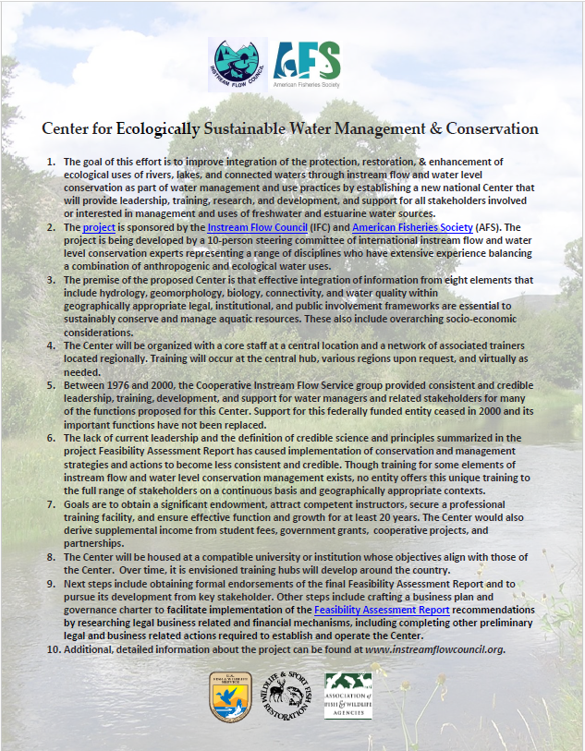
Attachment B

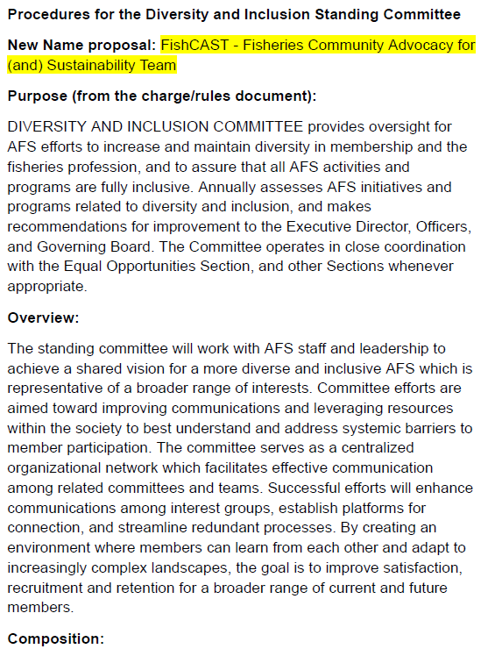

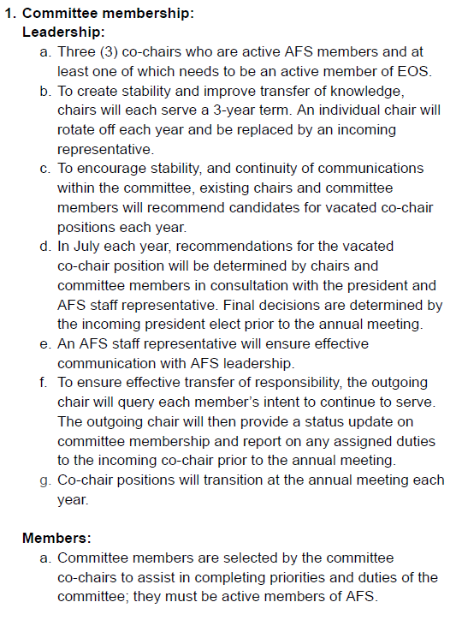
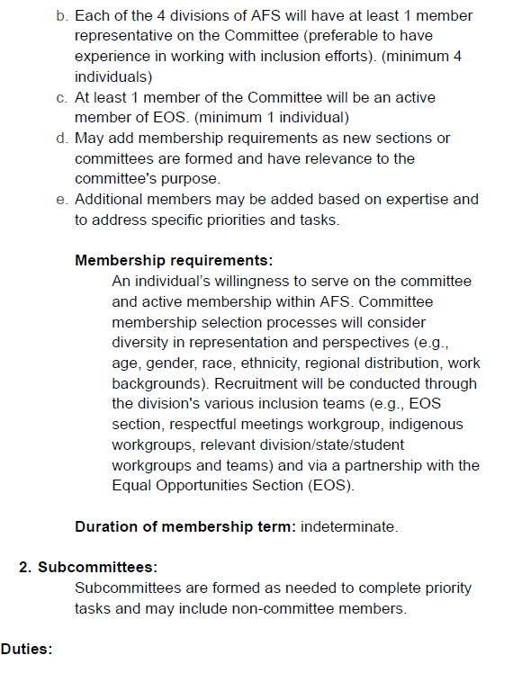
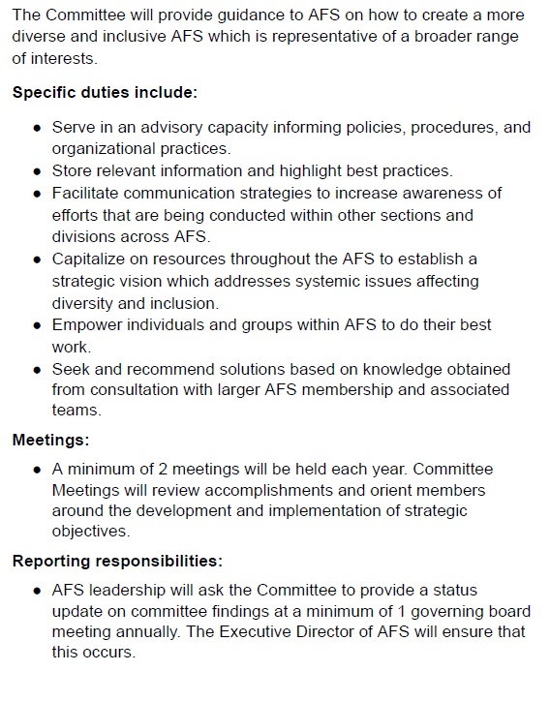

Attachment C

To: Officers
From: Lauren Maza and Doug Austen
Re: Re-thinking the Awards Program
Date: June 3, 2024

Please consider the comments and suggestions below as a starting point for discussion.

Issue:
One of the key features of AFS is the recognition of exceptional contributions to fisheries science and to the Society. The AFS awards program is an important part of the society with a rich tradition and history. Unfortunately, the AFS awards process has become increasingly complicated and unwieldy and is constantly hampered with limited submissions in many categories. Some awards are so similar to others that members frequently confuse their submission resulting in subsequent changes in their target award. In many years we receive no submissions for some awards and only one or two for others. In most years, submissions are late and require extraordinary reminders and delays in order to obtain submissions.

AFS offers awards in many categories and at many levels. This memo focuses on national level awards that are primarily presented at the annual meeting either during the plenary session or at the business meeting. These awards may be managed by an AFS Section or by the AFS Awards Committee.
- Award of Excellence
- Carl R. Sullivan Fishery Conservation Award
- Chapter Awards
- Distinguished Service Award
- Emmeline Moore Prize
- Emerging Leaders Mentorship Award
- Fellows Selection Committee
- Meritorious Service Award
- Mote Fisheries Fellowship
- President's Fishery Conservation Award
- William E. Ricker Resource Conservation Award
- Retired Member Travel Award
- Stanley Moberly Award

Comments
As an overview, the AFS (national level) awards are structured as outlined below:
- An overall Awards Chair presides over the committee (currently one of two chair positions are filled)
- Award subcommittees review applications for assigned awards

In the fall of 2022, AFS launched a new award application and review system (Award Force), to try streamlining the award processes. Leanne Roulson helped with creating a more standardized set of application requirements.

For the award subcommittees that have adopted use of Award Force, the system has proved helpful. The remaining issue is the numerous subcommittees that review specific awards. There is little consistency among the subcommittees regarding:

Adoption of the Award Force system – some awards use it, some have limited knowledge of the capabilities, some do not use it at all
Reviewer best practices – in order for the review portion of the system to work, there needs to be review criteria assigned to each award. Does a standard set of review criteria make sense?
Communication between award chairs and subcommittees – it has continually been difficult to determine how subcommittees have been “staffed” with volunteers; there has been little communication between Award Chair and subcommittee chairs and little collaboration among subcommittee chairs.

Recommendations

Based on what we have seen thus far in 2024 (as well as in recent years), I am suggesting the following in preparation for the 2025 award season:

Combine review committees for the following:
- Award of Excellence
- President’s Fishery Conservation Awards
- Sullivan Conservation Award
- Ricker Conservation Award
- Emmeline Moore Prize

Consider combining the following awards, since there has been confusion regarding what separates these categories:
- President’s Fishery Conservation Awards
- Sullivan Conservation Award
- Ricker Conservation Award

Consider combining:
Meritorious Service and Distinguished Service Awards – there have been minimal applications for these awards during the past few years.

Additional clarification and review needed for the following:
AFS Fellows
Audit language in procedures manual

Emerging Leaders Mentorship Program (ELMA)
Audit how nominees are submitted – through divisions and/or self-nominations by individuals

Skinner Travel Fund
There were almost 80 applications this year! The Skinner fund shows that messaging is being received by the membership and the award system is working!

Chapter Awards
Audit requirements and review process

Excellence in Public Outreach
Audit/reconfirm processes

William Mote Award
This was created in 2021 when AFS received funding from the Mote foundation. Revisit the best use of the remaining funds. Possibly combine funds with another related award

Attachment D

Removal of Vote Auditor from the AFS Rules and Procedures
For discussion only; no action requested at this time.
Background:
Historically, AFS used paper ballots or simplistic electronic voting (or a combination) for election of officers. This antiquated approach required a separate, independent count and audit of votes to ensure accuracy and transparency. This was the role and purpose of the AFS Audit Committee. For over a decade, AFS has been using electronic voting systems and currently uses a highly reputed independent vote software service Balloteer, developed by Telusys, Inc. This service provides a secure process for electronic voting by requiring all voters to enter the email address associated with their AFS membership and a PIN, which is generated specifically for each election, to access the online ballot. This eliminates the opportunity for inappropriate or multiple voting. It also provides a very simple tally of votes and a spreadsheet of all votes cast. There is no need or opportunity for an independent audit of the process because it is entirely transparent and automated. Due to this process update, it is proposed that the role of the Vote Auditor is no longer needed and should be removed from the AFS Rules and Procedures. Any review of the vote software contractor can be handled by AFS staff, the Management Committee, or the Nominating Committee.
Proposed Motion:
Motion #1: Move that the Management Committee vote to remove all content relevant to the Vote Auditor from the AFS Procedures as documented below.
Motion #2: The AFS Management Committee recommends that the Governing Board vote to bring before the AFS membership at the next appropriate opportunity the removal from the AFS Rules all language relevant to the AFS Audit Committee.

Current AFS Rules – Statements including the Vote Auditor
Section 1. Order of Business. Subsection h. Report of the Vote Auditor
Section 3. Officers, Staff, and Elections. Subsection B. Nomination and election of officers
- Members will be allowed at least 30 days from the distribution date to return their printed or electronic ballots to the Vote Auditor.

Section 14. Standing Committees
b. The Society has established the following standing committees:
- VOTE AUDITOR oversees procedures for electronic voting and officer elections. The Vote Auditor confirms the results of electronic votes (or for mail ballots, counts the election ballots), transmits the results to the President and Executive Director within 30 days of the closing date of the election or vote, and announces the results at the annual Society meeting or through other appropriate means. The Vote Auditor sends electronic results and/or mail ballots to the Executive Director, who shall hold them at least 90 days after the announcement of the results.

Current AFS Procedures

Vote Auditor
Purpose:
Verifies voting results and/or counts the election ballots, transmits the results to the AFS President and/or Unit Officer and Executive Director within the designated number of days of the closing date of the vote or election, and announces the results at the annual Society meeting or as appropriate. The Vote Auditor sends electronic results and/or ballots to the Executive Director, who shall hold them at least 90 days after the close of the vote or election.
Composition:
Vote Auditor and Co-Auditor are appointed by the AFS President for staggered two-year terms.
Duties:
1. Works with the AFS Officers or other unit leaders in the development of fair and equitable voting procedures designed to ensure that each member has an opportunity to vote confidentially and only once.
2. Participates in the selection of services to provide electronic voting capabilities to the Society. Individual units may be responsible for their own voting services, as appropriate.
3. May communicate with the service provider to obtain specific information on the process (e.g., adequate provisions for notification, accuracy, secrecy, equity, and qualification of voters).
4. In the case of Officer elections, works with the Executive Director to ensure that the Ballot is prepared and transmitted to the membership in May, with a 30-day response period that typically closes at the end of June.
5. Checks with electronic ballot service provider periodically to ensure election is running smoothly. As necessary, the Vote Auditor may count paper ballots received from members who do not have electronic access for voting.
6. Verifies results within 30 days after the deadline for ballot returns.
7. Transmits results to AFS President or appropriate Unit Officers and Executive Director immediately after verification or counting of votes.
8. Protects confidentiality of these processes; results shall not be discussed with anyone other than the AFS President or appropriate Unit Officers and the Executive Director.
Operational Guidelines:
None specified at this time

Attachment E

AFS Books Program Executive Summary 2023–2024

Overview and Background Information:
BEGINNINGS
Early History: The book program began in 1948 with the title A List of Common and Scientific Names of the Better Known Fishes of the United States and Canada, which became part of the Special Publications series. The Monograph series began in 1976 as a vehicle for lengthy papers on focused subjects. The Society began publishing unnumbered, nonserial books in 1976; these are now listed in our “Professional and Trade” category. Begun in 1987, our Symposium series publishes the proceedings of symposia primarily presented at AFS meetings.

Digital Age: Through a marketing agreement with the AFS Fisheries Information and Technology Section (FITS), AFS began selling FITS-sponsored software titles in 2010. In 2015, the AFS Online Bookstore began offering electronic versions (PDFs) of the full text of selected books and individual chapters.

NEW INITIATIVES
AFS Book Subscription Program: The AFS book subscription program was initiated in March 2020 to better utilize and increase visibility of the book program’s many book titles in electronic (PDF) format as well as increase revenue for the books program. The subscription program enables institutions to pay for unlimited access to nearly 100 AFS book titles in electronic format for a five-year term. Pricing is based on institutional membership status and the number of staff using the subscription.

e-Books and DOIs: In 2019, AFS President Jesse Trushenski appointed the AFS Special Committee on Books to analyze the state of the AFS books program and make recommendations for its improvement to the AFS Governing Board. Two recommendations put forward by the Special Committee included the development of electronic books (e-books) and the addition of digital object identifiers (DOIs) intended to enable the AFS books program to make use of the current technology and maintain its relevancy in modern times.
AFS released its first six e-book titles in the summer of 2020. DOIs were added to previously published book titles in March 2021 and have been added to every new title since.

In September 2022, AFS entered into an agreement with the Instream Flow Council to host and facilitate the digital sales of two of their books via our online bookstore. AFS retains 25% of the sales until the agreement is terminated.

Financial/budget (2023 budget; financial results of past three years):

The AFS Books Program has historically been revenue-generating and, more recently, self-supporting; however, sales have continued to decline in recent years, with a larger decline during the COVID-19 pandemic. In 2023, we saw sales begin to rebound.

Revenue sources: Online sales, direct sales to the fulfillment center, Book Subscription Program, book grants, funding obtained by individual editors and authors.
Expenses: Staff time and benefits, production costs, contract editors and/or indexers.
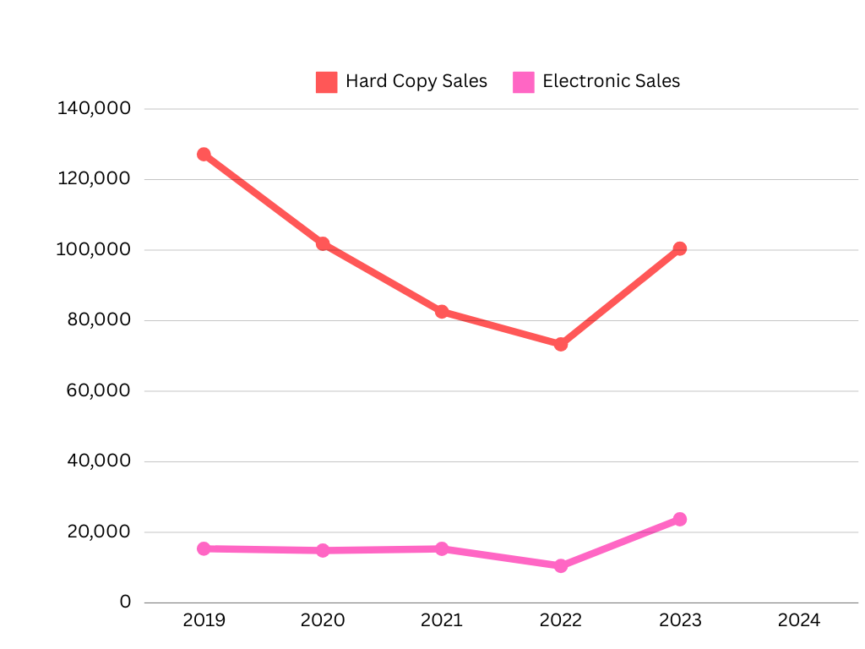

Metrics/ratios (past three years), such as gross/net profit margin, return on investment, renewal or resale %
- Books in the “Professional and Trade” category make up the majority of sales.
- Hard copy sales consistently outperform digital sales.
- Of electronic sales, PDFs outperform epub or mobi sales, when available, by a large margin.

Goals/Objectives:
- Determine Consumer Needs and Desired Titles. Due to a shrinking readership and an audience that consumes an ever-growing variety of media, it will be important to stay current on technologically relevant media while also determining what AFS members and the scientific community want to see. Many AFS products have a narrow focus, but it is important for AFS to continue to support these projects and be a home to projects that would be considered too small or narrow for a bigger/traditional publisher to take on.
Projected Completion: Ongoing
- Streamline Decision Making Processes. To streamline the book proposal process, proposals will now be shepherded through the proposal period by a Book Production Editor. The assigned Editor will assist proposers with reviewing and updating the proposed project and include financial analyses.
Projected Completion: Current, ongoing
- Improve Book Marketing. Book Production Editors have been working with our Membership Department to develop a revitalized postpublication marketing plan. The continued value of traditional book reviews will also be evaluated.
Projected Completion: 2024
- Review Pricing and Royalties Structure. Royalty payment structures are currently being assessed. In recent years, AFS Sections have received lower or more infrequent royalty payments from the program. We will need to analyze these trends and better understand the various agreements/arrangements that have been made in the past. We will also explore other potential partnerships. Additionally, pricing structures are being reassessed to determine if our books are competitively priced while also serving the needs of membership. For example, Sections that support publications, authors, or editors may want the final product to be more affordable for certain audiences (e.g., students).
Projected Completion: 2025
- Increase Discoverability and Promotion. Authors of AFS books have reported that our library is not being discovered by online indexing services, such as Google Scholar. We will need to assess if the recent website redesign has improved discoverability. This assessment may also include contracting professional expertise and a possible cost/benefit analysis of moving the online bookstore onto another platform or website.
Projected Completion: 2025
- Digitization of Back Catalog. Most of AFS’ older book titles are only available in limited hard copy quantities; electronic versions are not available. Options for digitizing the remaining library will need to be researched.
Projected Completion: 2025
- Potential Publishing Partnerships. As AFS looks to pursue more diverse titles and a wider readership, there is a potential to partner with other societies on joint book projects. It could be particularly beneficial to partner with other, smaller societies, such as those in CASS, who do not have their own publishing arm. The potential will have to be explored with these other societies.
Projected Completion: 2025

Attachment F

